Catch-ups – Design Specification
Document Name: Catch-ups Design Specification
Version: v4.0
Prepared By: Engineering Team
Date: 01-29-2025
Status: Approved
1. Purpose
This document provides a detailed functional and UI design specification for the Catch-ups module. It defines how conversations are captured and displayed for a ticket, with special focus on:
- Logging the relevant email conversations related to a ticket
- Maintaining the complete timeline of conversations for contextuality.
- Notes with versioning and mutability.
The document is intended for Product, Design, and Engineering teams to ensure a shared and unambiguous understanding.

2. Scope
This specification covers:
- Catch-ups overview and objectives
- Conversation triggering points
- Catch-ups timeline
- Notes
- Chatbot Catch-ups
- Email conversations initiated via email clients and application
- Permissions and edit rules
- Versioning of Ticket Titles and Descriptions
- Email Subject Line changes and behaviour of the application in handling the conversations

3. Catch-ups Overview
The Catch-ups module acts as a unified conversation timeline for a ticket. It consolidates all related communication.
Catch-ups ensure:
- Contextual continuity of conversations and traceability of communication
- Seamless collaboration between internal users and all stakeholders related to the ticket
- Checkbox-based filtering of catch-ups types with multi-select capability to ensure comprehensive view of the conversations occurring for the specified ticket
3.1 Catch-ups Types
The system supports the following catch-ups types:
- Email
- Notes
- Chatbot (via WhatsApp)

3.2 Catch-ups View Specifications
- When Email is selected as the only filter, emails are grouped by conversation threads and displayed in an accordion view. Each thread can be expanded to view all associated emails in chronological or reverse chronological order specific to that thread.
- When multiple catch-up types are selected, or when Email is selected along with any other type, emails are no longer grouped by thread. Instead, all catch-ups (emails, chatbot notes, and notes) are displayed as individual entries in a single, unified timeline sorted in chronological or reverse chronological order.
- While selecting multiple catch-ups the user will get a notification stating that emails will no longer be grouped by threads.

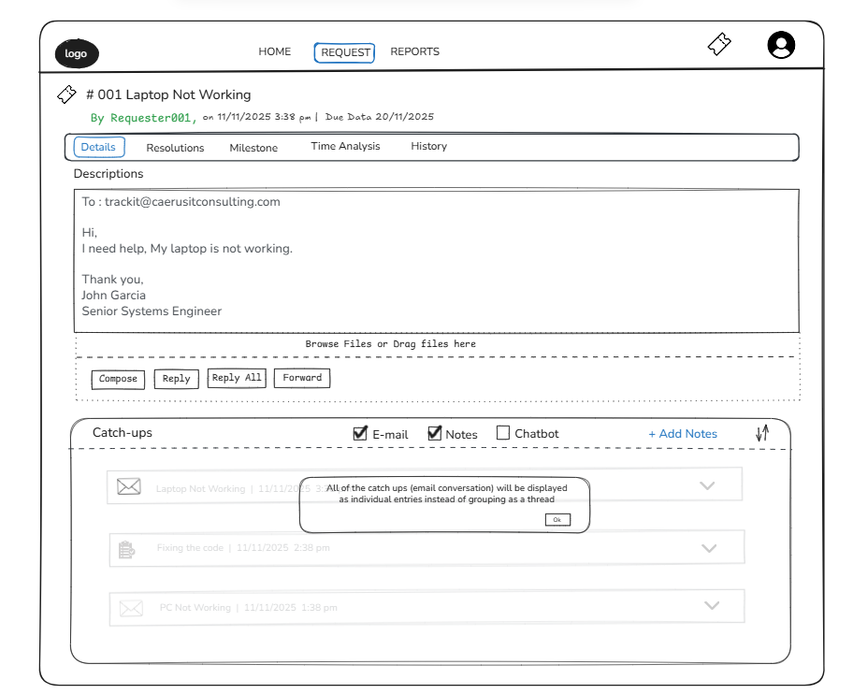

4. Catch-ups Timeline Behaviour
- Catch-ups are displayed in chronological or in reverse chronological order, depending on the sorting type selected.
- Each entry clearly shows:
  - Conversation type (Email / Note)
  - Author
  - Timestamp
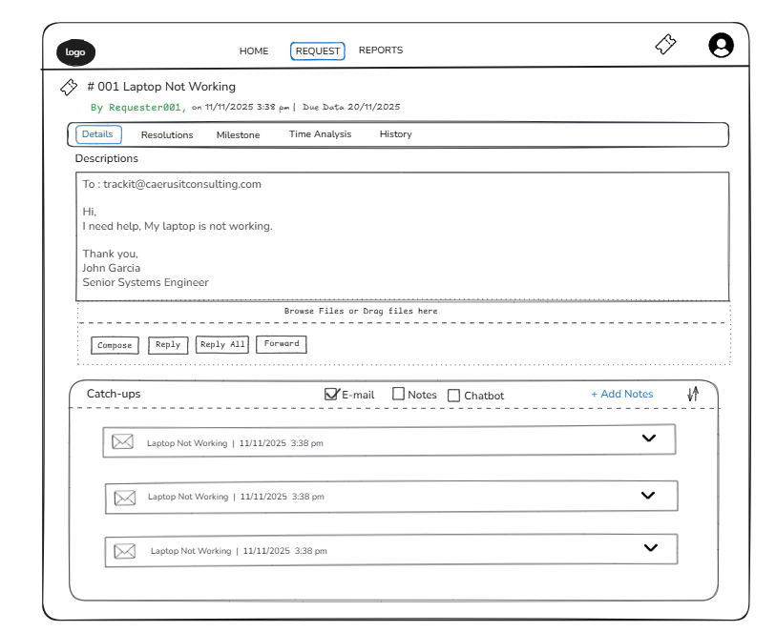
Conversation entries are read-only, except Notes (see Section 5).

5. Notes – Detailed Specification
5.1 Notes Overview
Notes are internal conversations used for collaboration among internal users.
- Notes always appear in the Catch-ups timeline.
- Notes are mutable and can be edited with proper versioning maintained.

5.2 Notes Creation or Initiation Method
- Notes can be added from the Catch-ups section by clicking on + Add Notes Button on top right corner of the Catchup section.
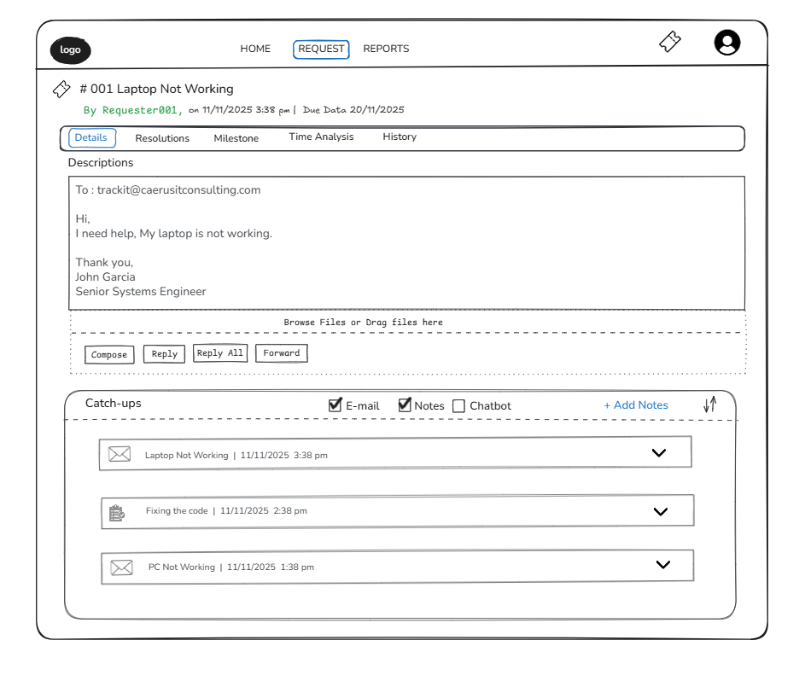
- Uses a rich text editor in a modal (CQE).
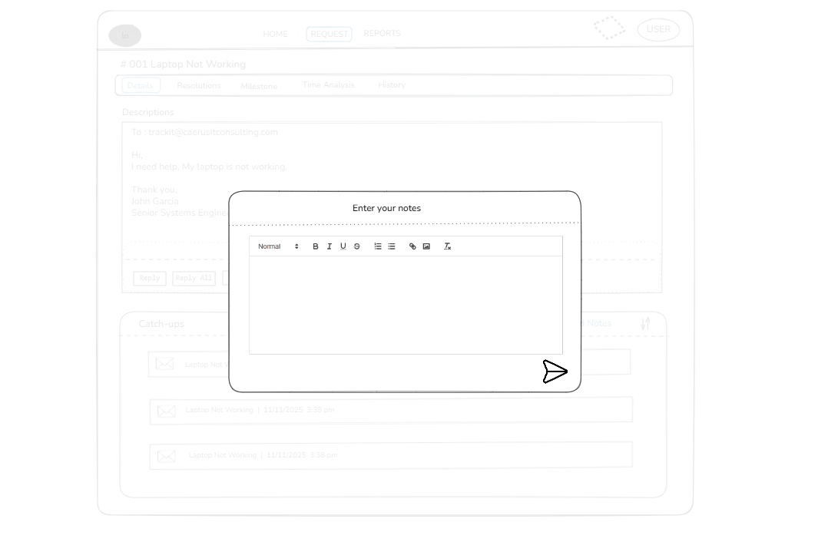

5.3 Notes Versioning System
Versioning Behaviour:
- Every update to a Note creates a new version
- Older versions are preserved permanently
Version Icon Interaction: When navigating through paginated versions of a particular note, the user should be able to observe that the older versions have slightly reduced opacity.
Each Version Displays:
- Edited date & time
- Contents for the particular version(read-only)
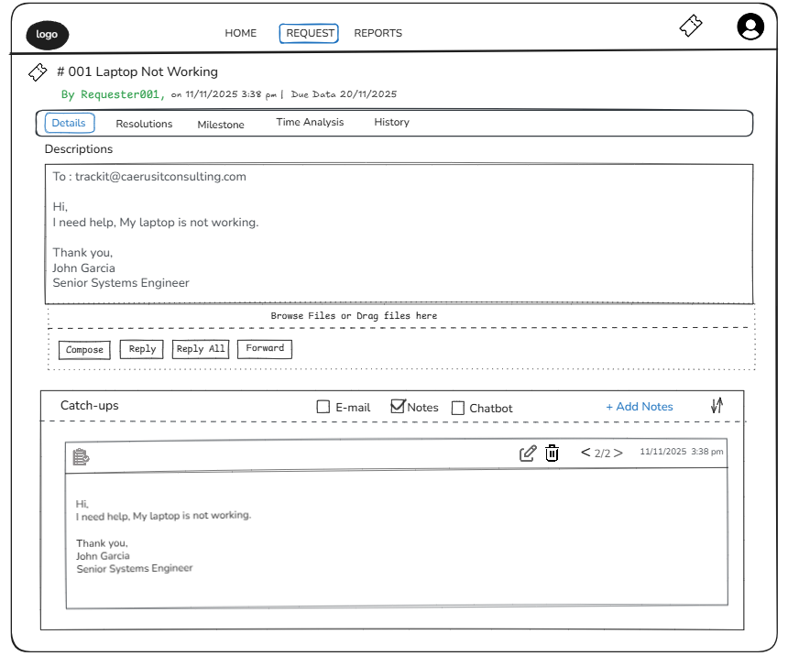

5.4 Notes Edit Permissions
Edit Rule:
- A Note can be edited only by the user who created it by clicking on edit icon
- A Note can be deleted only by the user who created it by clicking on delete icon, which will remain visible only for the first 15 minutes following the creation of that note.
Behaviour for Other Users:
- Notes are visible but read-only
- Edit option is hidden or disabled
Attributes Stored:
- Created by
- Created timestamp
- Last updated timestamp

5.5 User Mentions in Notes
- When a technician mentions another technician using @username:
  - An email notification and WhatsApp chatbot notification are automatically triggered.
  - The notification includes:
    - Ticket Reference ID
    - Ticket Title
    - Direct URL to the ticket

6. Chatbot Catch-ups
- The chatbot section under the catch-ups module records the interactions with the chatbot, which for now includes but not limited to notes created via chatbot.
- The rules governing the creation, updation and deletion of chatbot catch-ups have been described in detail in the Conversation Chatbot Document.

7. Email Conversations in Catch-ups
Email conversations related to a ticket, regardless of whether those emails are sent from an external email client or from Trackit, are captured as email Catch-ups for that ticket, ensuring that all email-based communications remains linked to the relevant ticket.
7.1 Email Capture Rules
An email will be captured as an email catch-up for a particular ticket only if one of the following conditions are met:
- The email is sent using the application itself by replying to an existing email catch-up. The reply will be sent programmatically by targeting the Message ID of the email message tied to that catch-up.
- It is sent from the application by replying to the ticket description, using the Message ID of the email that originally created the ticket. This applies only to tickets created via external email.
- The email is sent using an external email client, by relying to the email thread that was originally used to create the ticket and by ensuring that the email address for the TrackIt agent(solutions@trackit.com) is included in the recipient list (To or CC).

7.2 Actions from the Application related to email
- Technicians can initiate a new email thread using the Compose button (regardless of whether the ticket is tied to a Message ID or not), or simply reply to an email catch-up from an existing conversation using Reply, Reply All, or Forward.
- The buttons ‘Reply’, ‘Reply All’ and ‘Forward’, associated with the Ticket Description will not be available for tickets created using the application or the WA chatbot.
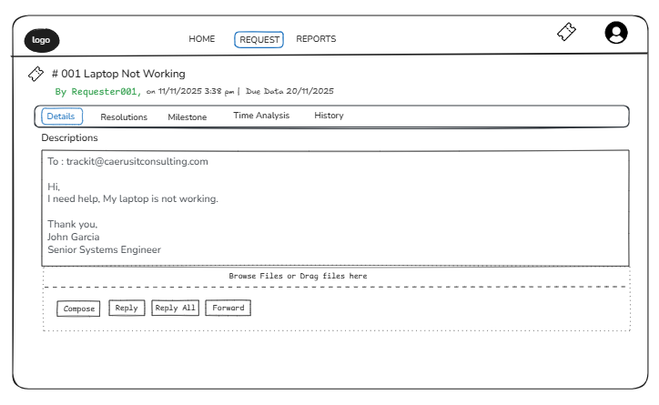
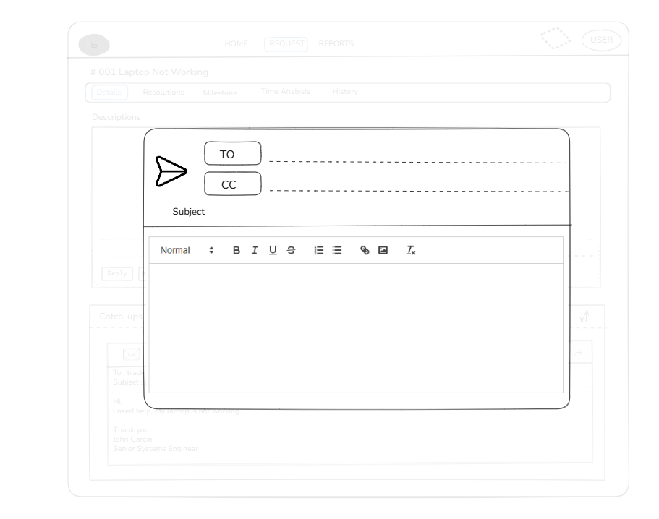
Fig: On base of user action (Reply / Reply All / Forward) the content will be auto adjusted
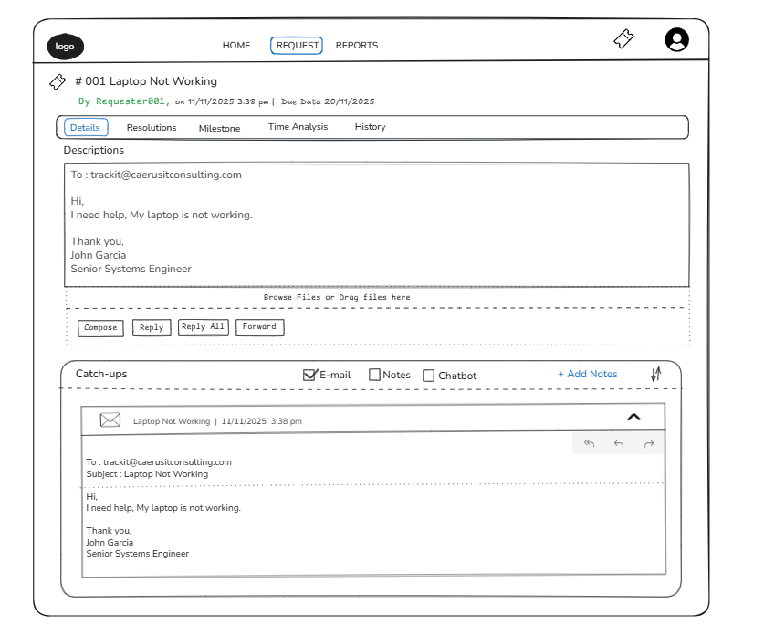

7.3 Email Subject Behaviour
- Email conversations initiated from the application will have the current version of ticket title as their subject line and it will be immutable. Any conversations in that thread retain the subject.
- While replying to the emails from an external email client the technician must not change the subject line of the conversation as it will create a new ticket in the application. Any conversations via the external email client will have the same subject line as the email being replied to. The ticket title can only be updated through the application itself.
- If the ticket title is altered from the application and the technician replies to the existing conversations, then the previous title is continued as the subject line. However, if the technician composes a new email under the description section of the ticket then a new email along with a new email thread is created and the subject for that email is the current version of the ticket title along with the ticket ID.
- To ascertain that the conversation belongs to that ticket and is appended to the appropriate ticket, Trackit will perform a group by and fetch all the thread ids currently related to a ticket and match and if it does not get a matched thread ID it will create a new ticket.
7.4 Maintaining Multiple Threads for each E-mail
- Email catch-ups will be grouped based on the thread they belong to for a better visual representation of their origin.
- Both Message ID as well as Thread ID of the email message that triggered the ticket (only in case of tickets created via email) will be mapped to that ticket. Replying to the Ticket Description would essentially mean replying to that email message on that thread.

8. Contextual Ticket Visibility and Access Control
- If a user is mentioned in a conversation:
  - They can view:
    - Notes where they are mentioned
    - Notes created by themselves
- To view the entire conversation history:
  - The user must request access.
  - An approval request is sent to the ticket assignee’s worklist.
- Upon approval:
  - Full conversation visibility is granted.
- Direct navigation from notification to ticket is supported via URL.

9. Audit & Compliance
The Catch-ups module ensures full audit readiness:
- No email conversation can be modified
- Notes retain complete version history

10. Summary
The Catch-ups module provides a structured, traceable, and secure communication layer for tickets. By clearly defining triggering points, enforcing email rules, and introducing controlled note versioning, the system ensures consistency, accountability, and collaboration efficiency.

